**Homework_4: Exploration of Landsat satellite imagery with R and QGIS**

**胡青 SA22008306**

1. Utilizing openstreesmap plugin in QGIS to find and download the map of the Doubs river (map: https://www.openstreetmap.org/relation/156145#map=9/47.1085/6.1057&layers=H), and download the map as a geojson format, which is becoming popular for encoding a variety of geographic data structures.

Openstreetmap打不开，采用quickOSM搜索Doubs river，搜索如下：

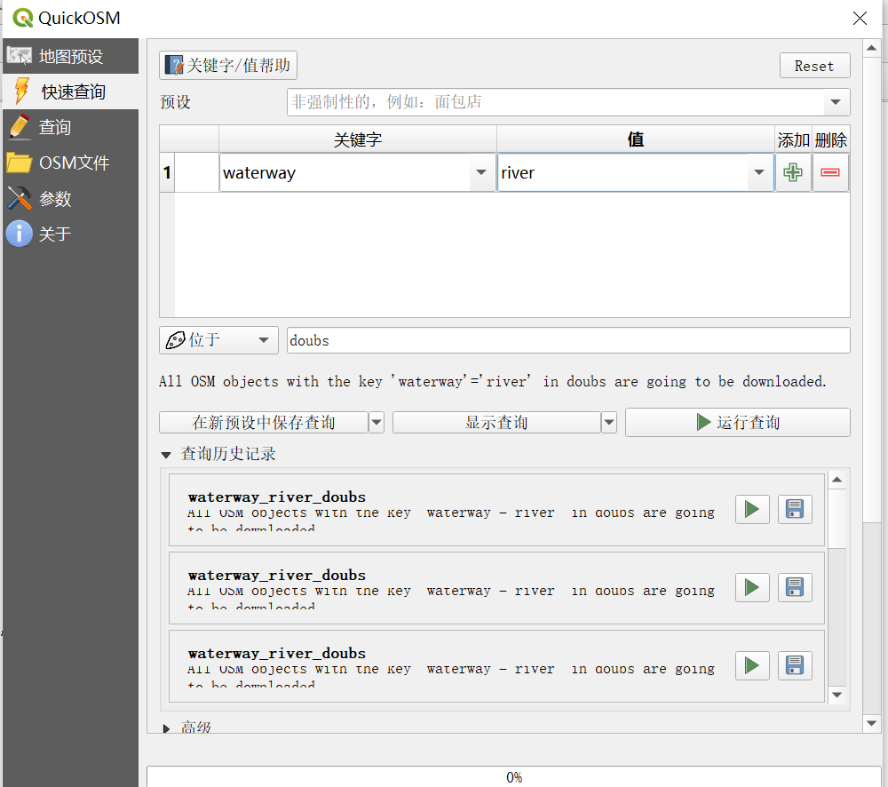

搜索结果如下：

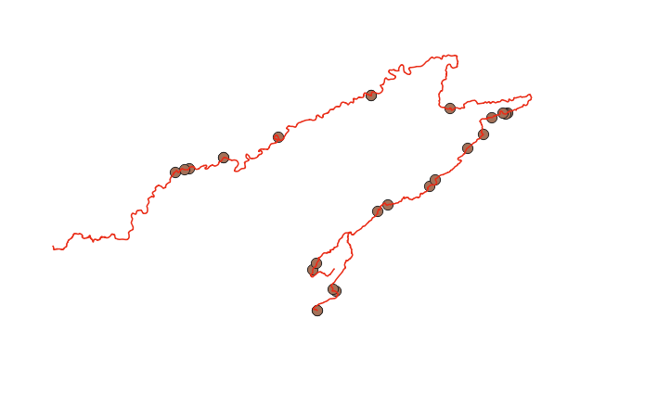

随后保存为geojson格式

2. You’d better to check the structure of the regions object by plotting the simple feature collection and dissolve the internal boundaries of the region if the geojson file contains. After that, please set the area that the river undergoes as the area of interest (AOI).

这个图本来就符合要求，不需要再融化内部边界，但需要画出AOI，AOI区域如下：

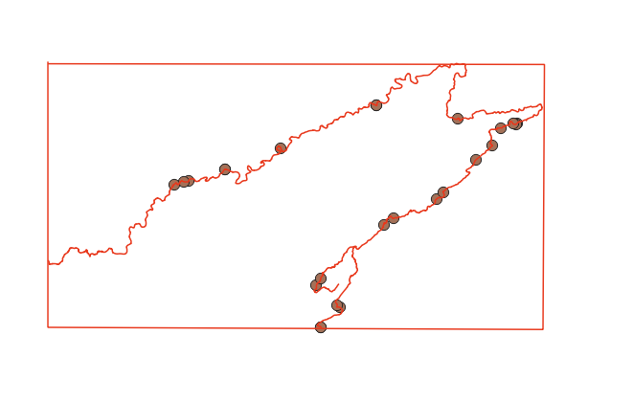

3. Create an account of one of these geospatial official websites, such as USGS, EARTHDATA, Copernicus data space, and login in for check the images that the river covers. Filtering the records to keep only Landsat images with LandCloudCover lower than 10%, and try to find what products levels. Please note whether the records contain sr_ndvi. The normalized difference vegetation index, NDVI, provides a rough estimate of the abundance of healthy vegetation and provides a means of monitoring changes in vegetation over time. You can download through manual methods directly from the geospatial websites or by other means, including QGIS and R package.

登陆USGA并注册，随后将AOI区域设为KML文件，用该KML文件去选择要下载的NDVI范围

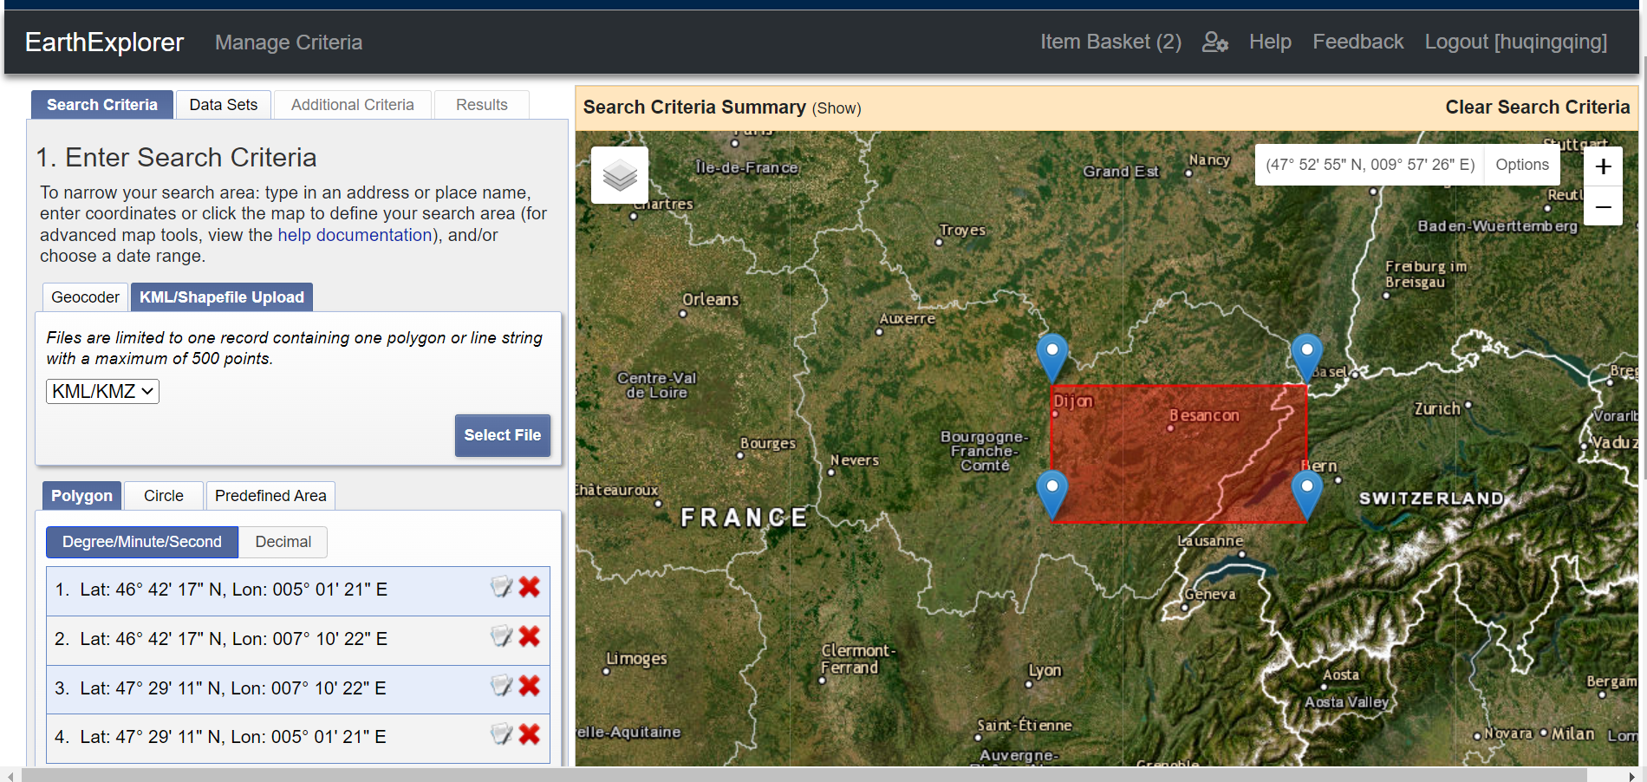

设置云量小于10%

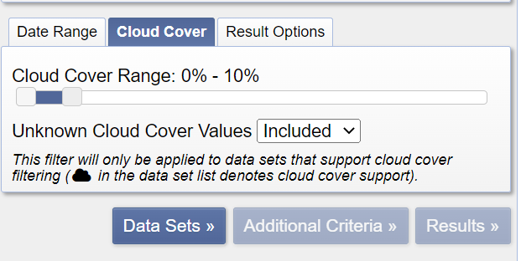

选择需要的数据类型

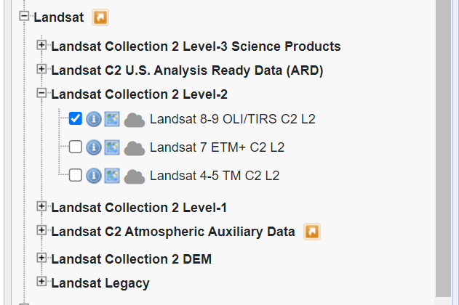

选择可以覆盖目标区域的足够数量的NDVI图，然后下载

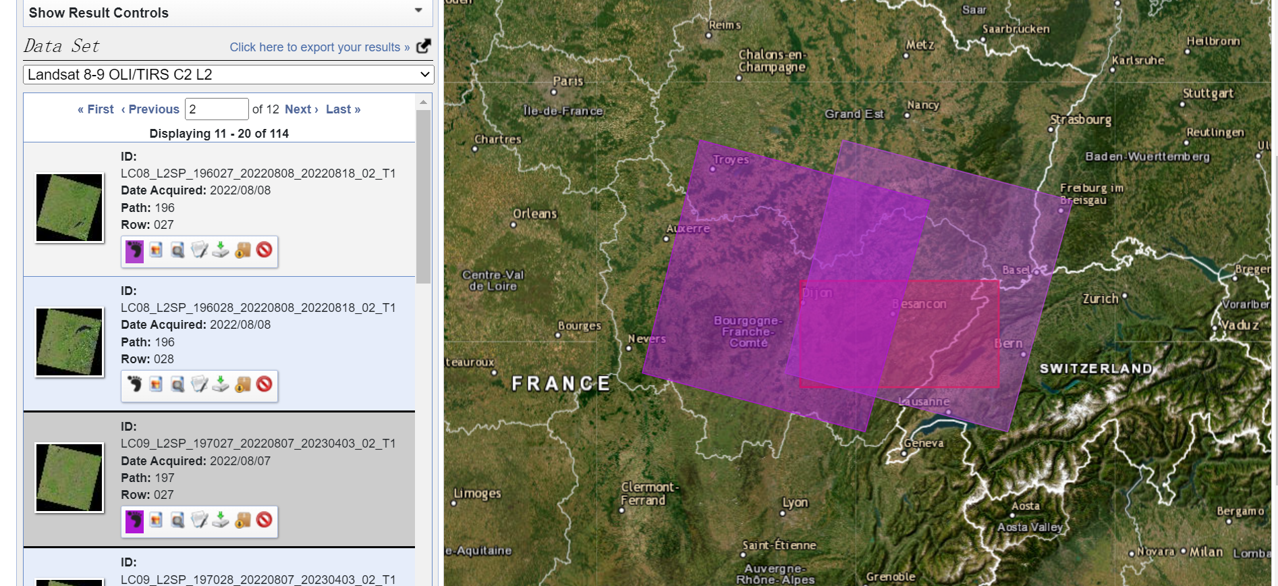

4. Load the NDVI raster file and check whether its crs is identical to AOI. If not, transform the crs of AOI vector into the another which is the same as that of NDVI. After that, you can crop and mask the NDVI for a small area, which just covers the AOI. Plot the cropped NDVI.

将两张tif栅格文件加载到图层中并进行合并

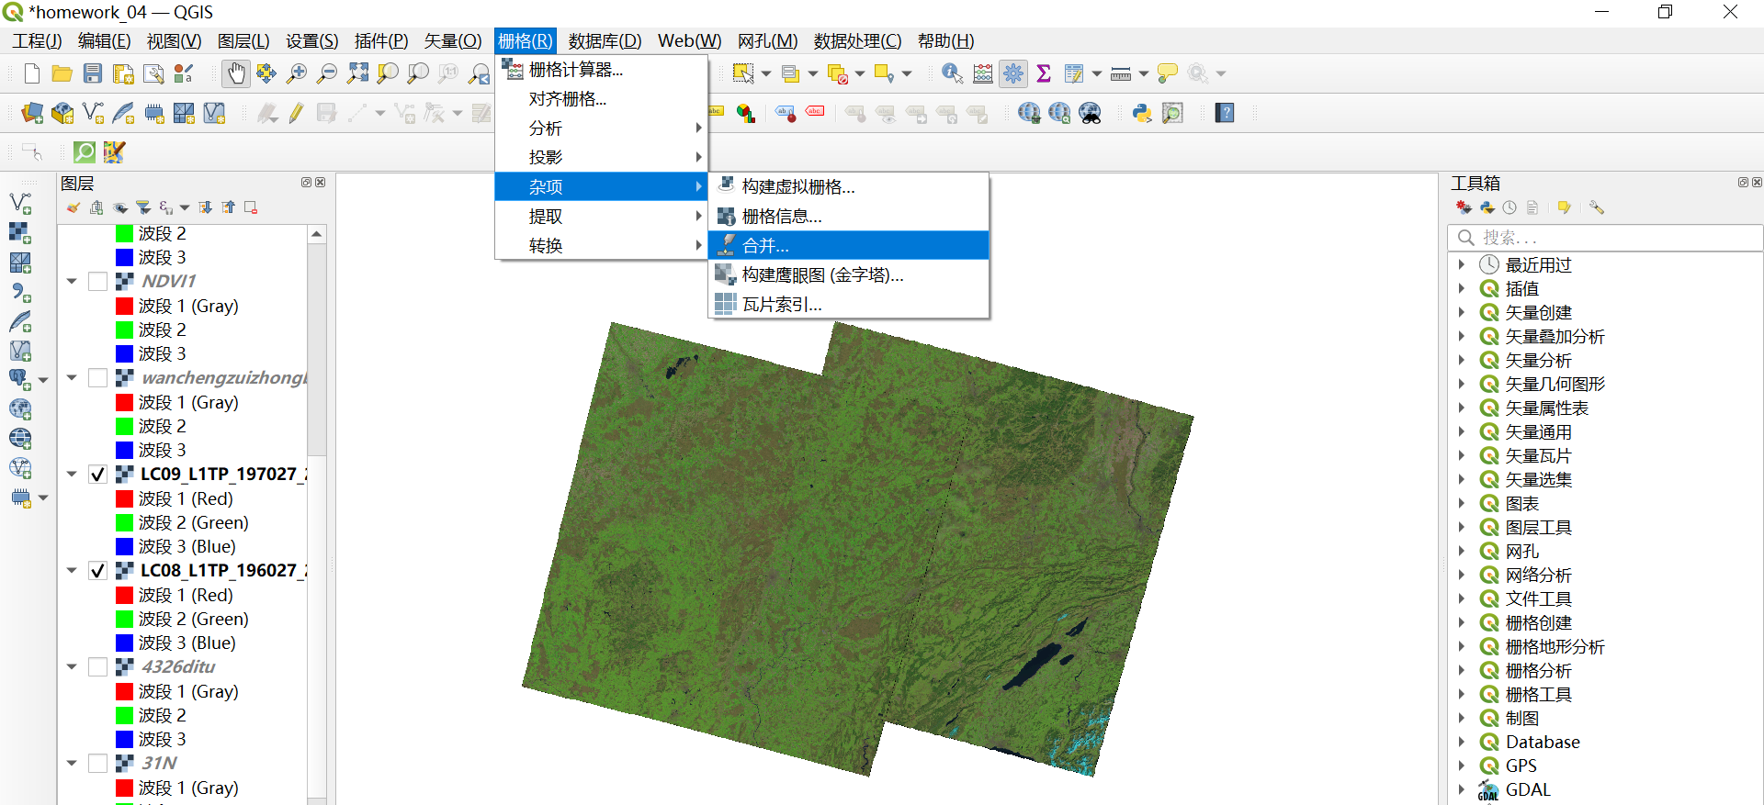

合并时注意查看crs是否相同，合并后转化为doubs矢量河流对应的crs：EPSG：4326-WGS 84，否则裁剪出错

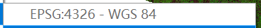

合并并转化为crs：EPSG：4326-WGS 84栅格图如下：

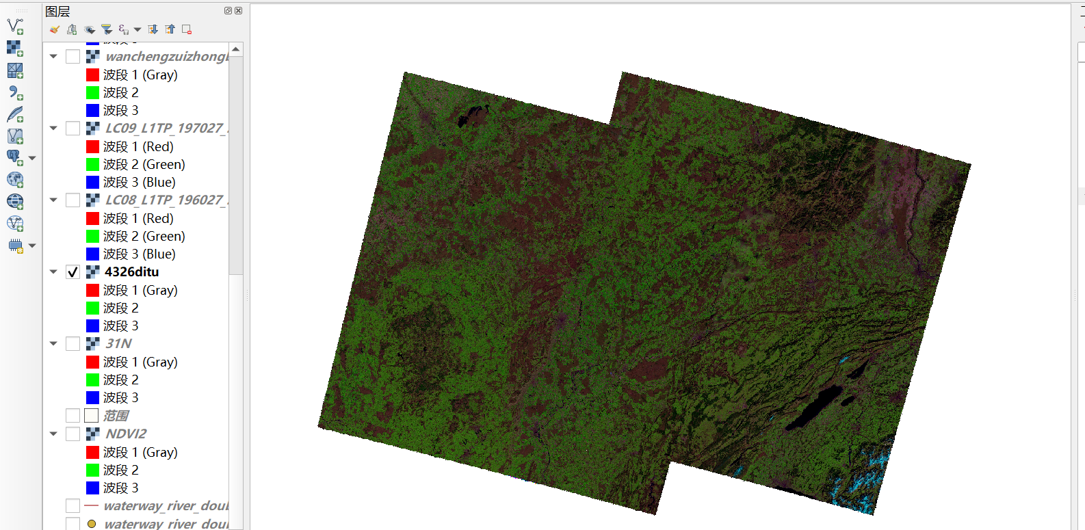

用Doubs河矢量去裁剪NDVI合并后的栅格：

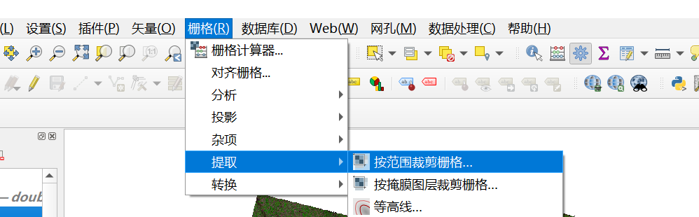

裁剪后栅格如图所示：

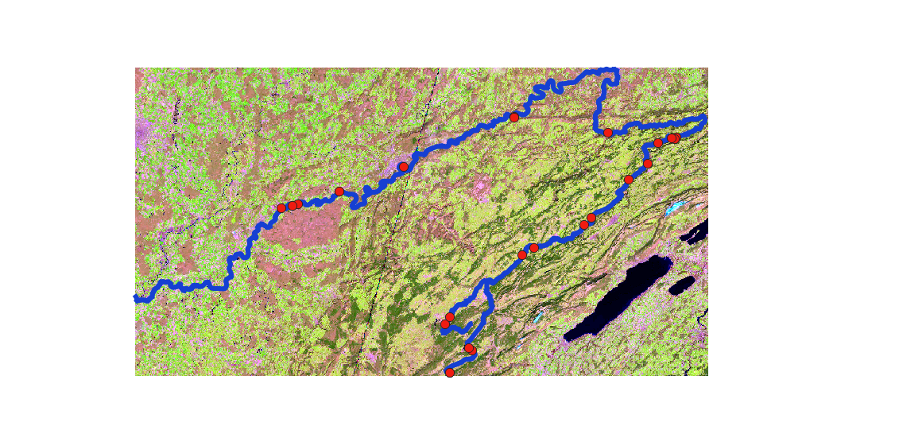

加上背景图层，最终结果：

